LAB ACTIVITY (Exp-01)

1. Maximum Subarray Sum - Kadane's Algorithm

Given an integer array arr[], find the subarray (containing at least one element) which has the maximum possible sum, and return that sum

Brute Force Method:-

#include <stdio.h>
#include <limits.h>

void findMaxSubarrayBruteForce(int arr[], int n) {
int maxSum = INT_MIN;
int startIdx = -1;
int endIdx = -1;

for (int i = 0; i < n; i++) {
int currentSum = 0;

for (int j = i; j < n; j++) {
currentSum += arr[j];

if (currentSum > maxSum) {
maxSum = currentSum;
startIdx = i;
endIdx = j;
}
}
}

printf("Maximum Subarray Sum: %d\n", maxSum);
printf("Subarray: [");
for (int k = startIdx; k <= endIdx; k++) {
printf("%d", arr[k]);
if (k < endIdx) {
printf(", ");
}
}
printf("]\n");
}

int main() {
int n;
printf("Enter the length of array: ");
scanf("%d",&n);

int arr[n],i;
printf("Enter the values of array");
for(i=0;i<n;i++){
scanf("%d",&arr[i]);
}

findMaxSubarrayBruteForce(arr, n);

return 0;
}

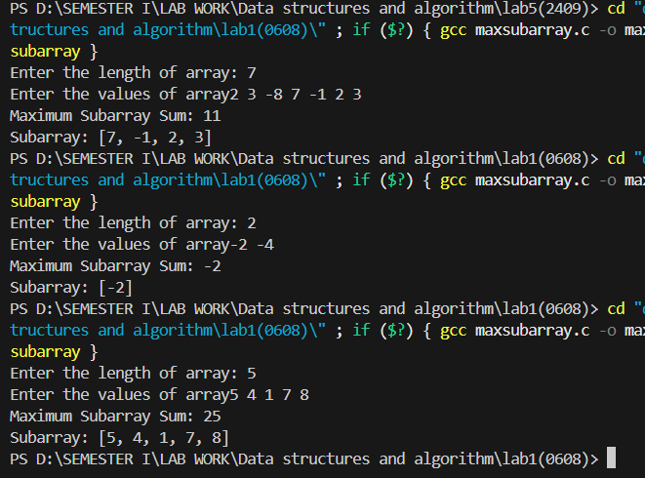

Dynamic Method:-

#include<stdio.h>

void main() {
int n;
printf("Enter the length of array: ");
scanf("%d",&n);

int arr[n],i;
printf("Enter the values of array");
for(i=0;i<n;i++){
scanf("%d",&arr[i]);
}

int max_c= arr[0];
int max_g=arr[0];
int start=0,end=0,s=0;
for(i=1;i<n;i++){
if(arr[i]>(max_c+arr[i])){
max_c=arr[i];
s=i;
}
else
max_c=max_c+arr[i];
if(max_c>max_g){
max_g=max_c;
start=s;
end=i;
}
}
printf("Maximum Subarray Sum: %d\n", max_g);
printf("Subarray: [");
for (int k = start; k <= end; k++) {
printf("%d", arr[k]);
if (k < end) {
printf(", ");
}
}
printf("]\n");
}

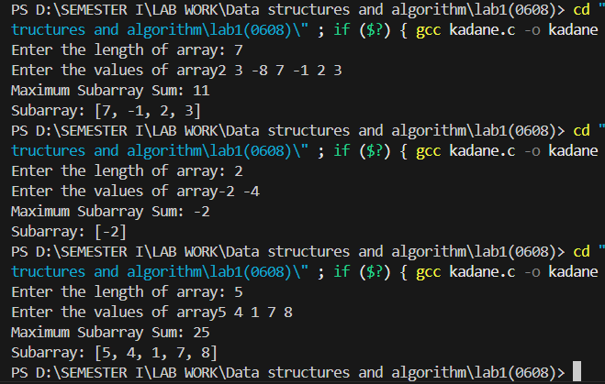

2. Maximum consecutive ones after flipping zeroes
- Input Array
- Constant value=k (the no. of zeroes you can flip)

#include<stdio.h>
#include<stdlib.h>

void main(){
int n;
printf("Enter the length of array: ");
scanf("%d",&n);

int arr[n],i;
printf("Enter the values of array");
for(i=0;i<n;i++){
scanf("%d",&arr[i]);
}
int k;
printf("Enter the value of k: ");
scanf("%d",&k);

int left = 0;
int right = 0;
int zeroCount = 0;
int maxLen = 0;

while (right < n) {
if (arr[right] == 0) {
zeroCount++;
}

while (zeroCount > k) {
if (arr[left] == 0) {
zeroCount--;
}
left++;
}

int currentWindowLength = right - left + 1;
if (currentWindowLength > maxLen) {
maxLen = currentWindowLength;
}

right++;
}

printf("Maximum consecutive ones after flipping at most %d zeros: %d\n", k, maxLen);

}

